**Level Ideas by Tamina Brunke**Square = Rage Triangle= Anxiety Circle = Sadness  
The Images do not reflect the scale of the actual game.  **(1) Introduction level idea - Rage(very easy)**

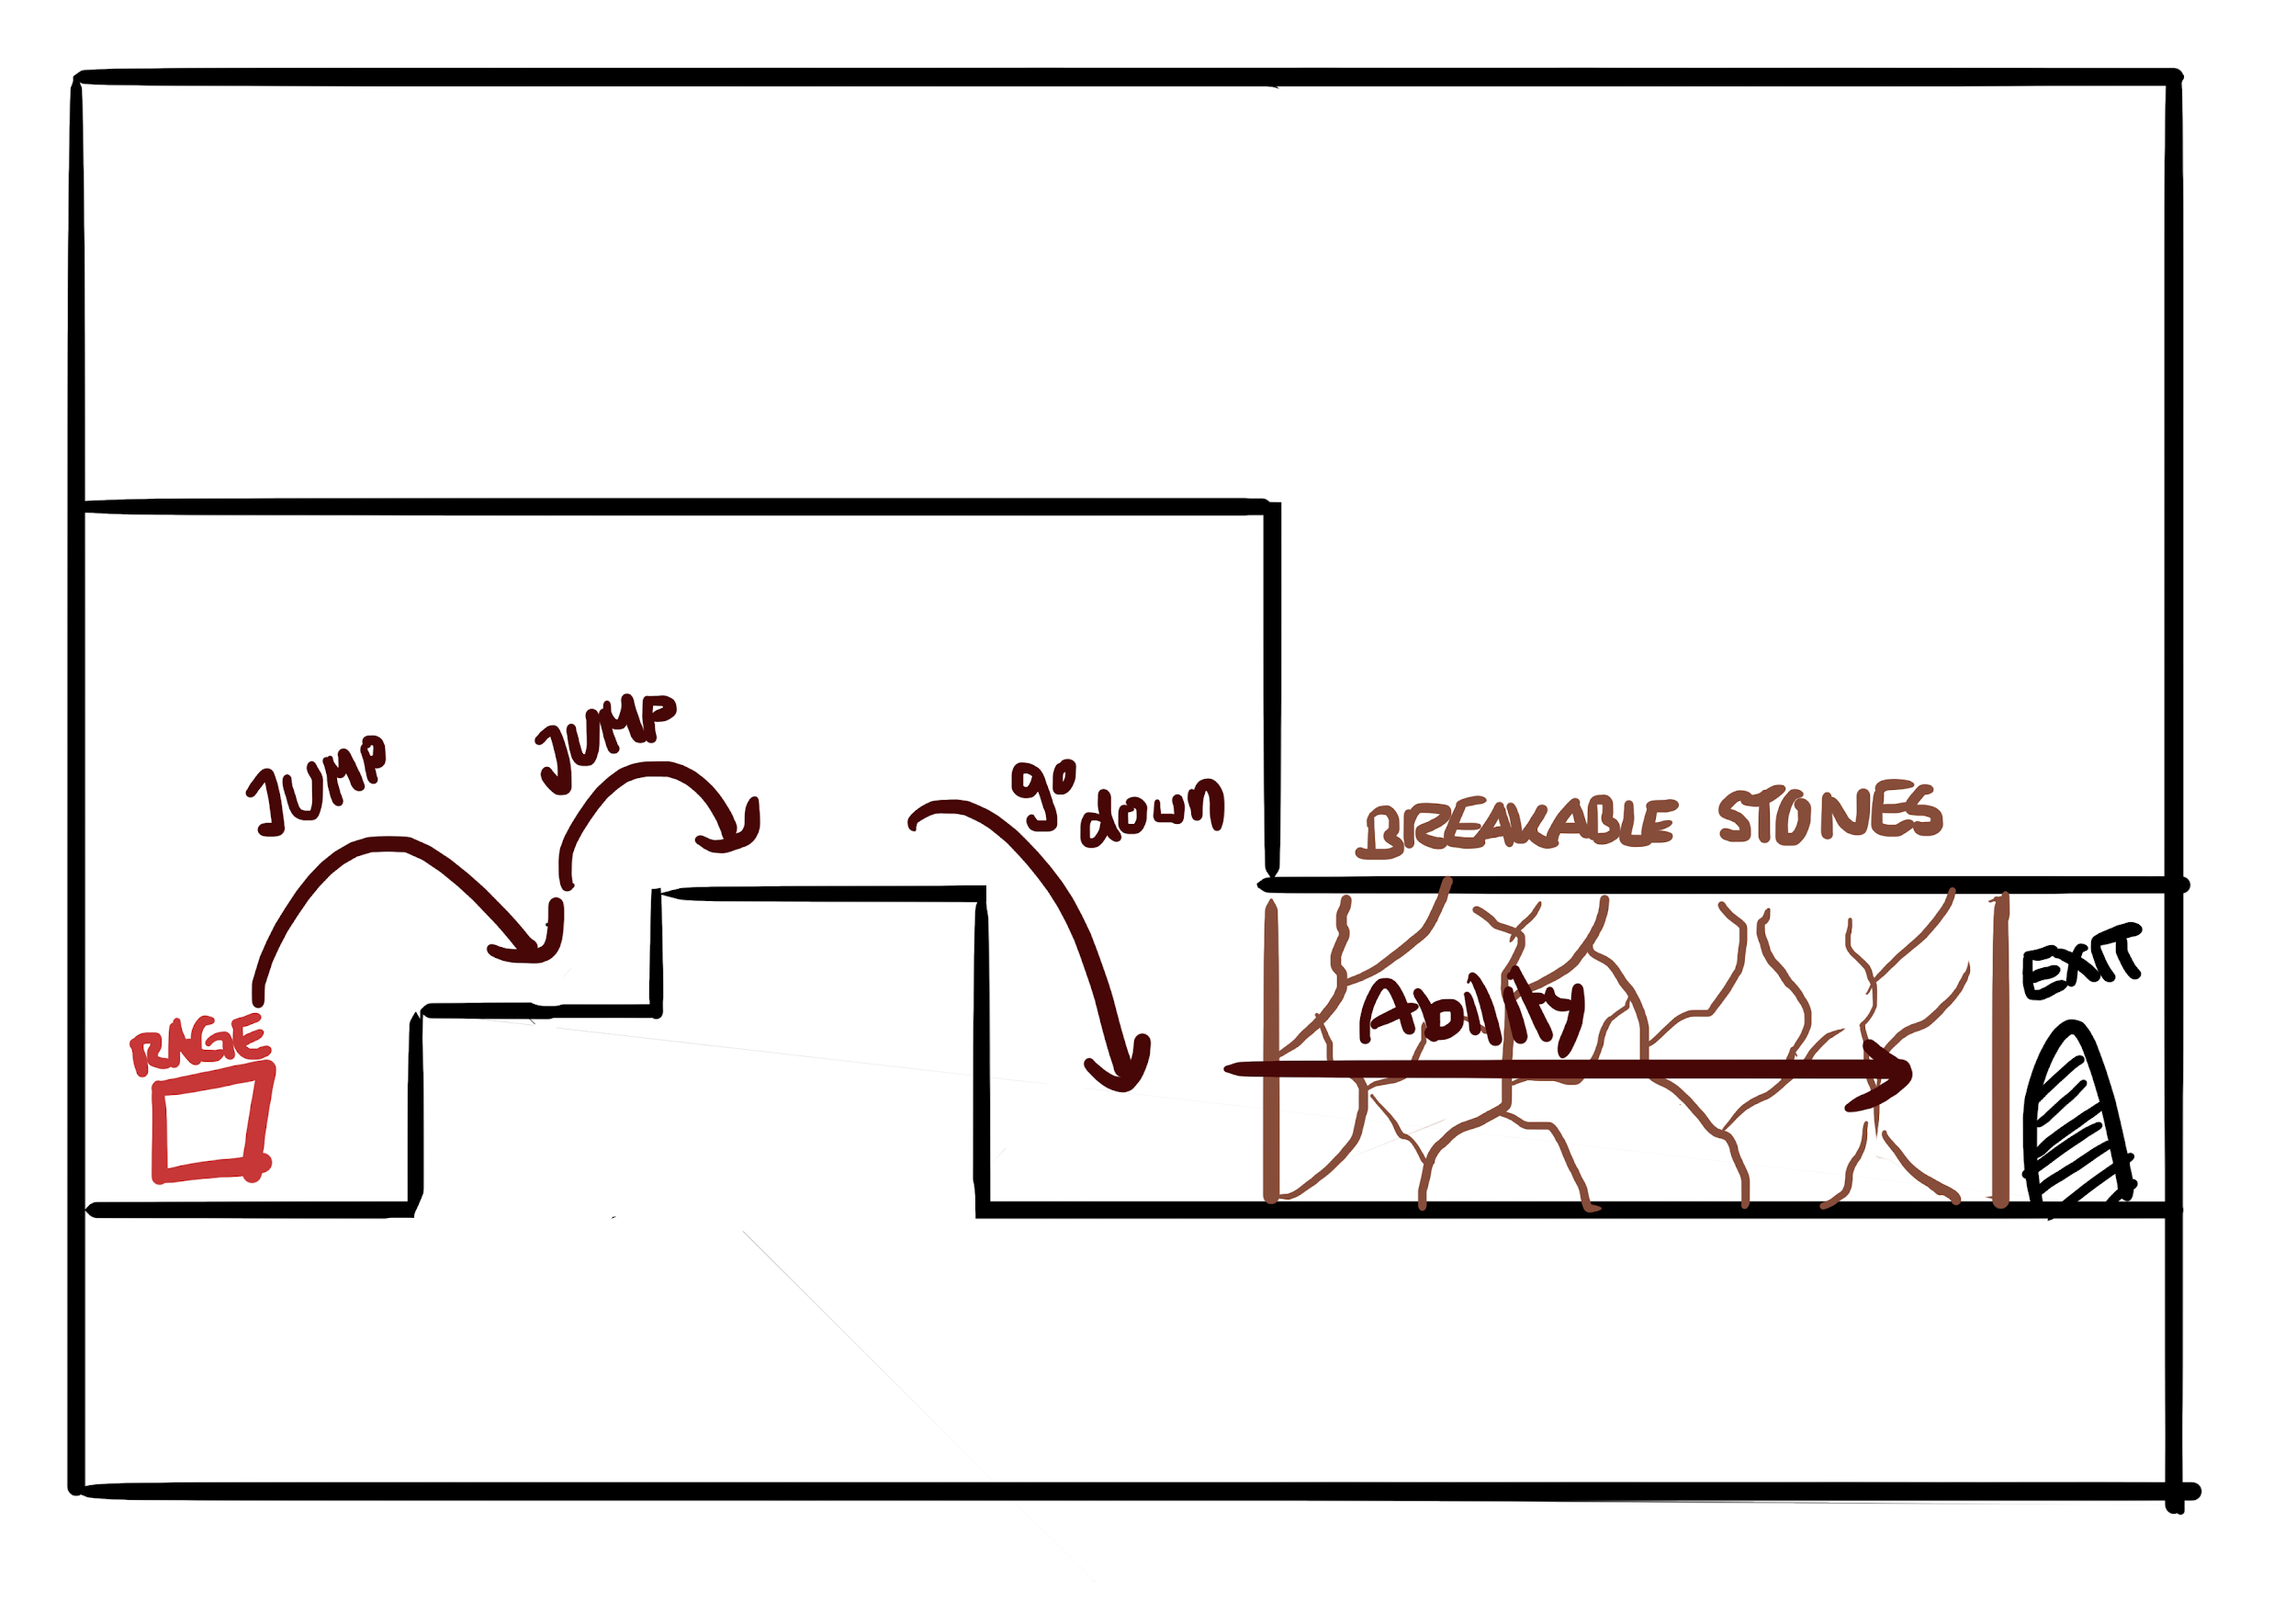**Purpose:** Introduce the player to the player controls, the character *Rage* and its’ abilities  
**Character:** Rage  
**Interactive Objects:** Destructible stone (wall)  
**Solution (you can see it in the picture):**1. Jump onto the solid platforms  
2. Walk or jump off  
3. User your ability and run through the exit.   
 **Questions:**   
-In the first Idea: activate Anxiety's ability **mid-air**, causing it to freeze up and land on the spikes leads to the following question:  
What would happen if anger starts his ability “mid-air” or on a platform.  
Would he just run straight forward without dropping or will he drop down to the ground?   
 -> Answered during meeting on 06.12.2018: he drops to the ground.   
- Is he running all the time after he used his ability (like running against the wall and the running animation just continues) or is he running against the wall full speed, crashing into it and gets kind of dizzy and that’s the reason why he can’t move again.  
 -> Answered during meeting on 06.12.2018: he runs against the wall and then gets   
 “dizzy”

**(2) Introduction level idea - Rage and Sadness (very easy)**

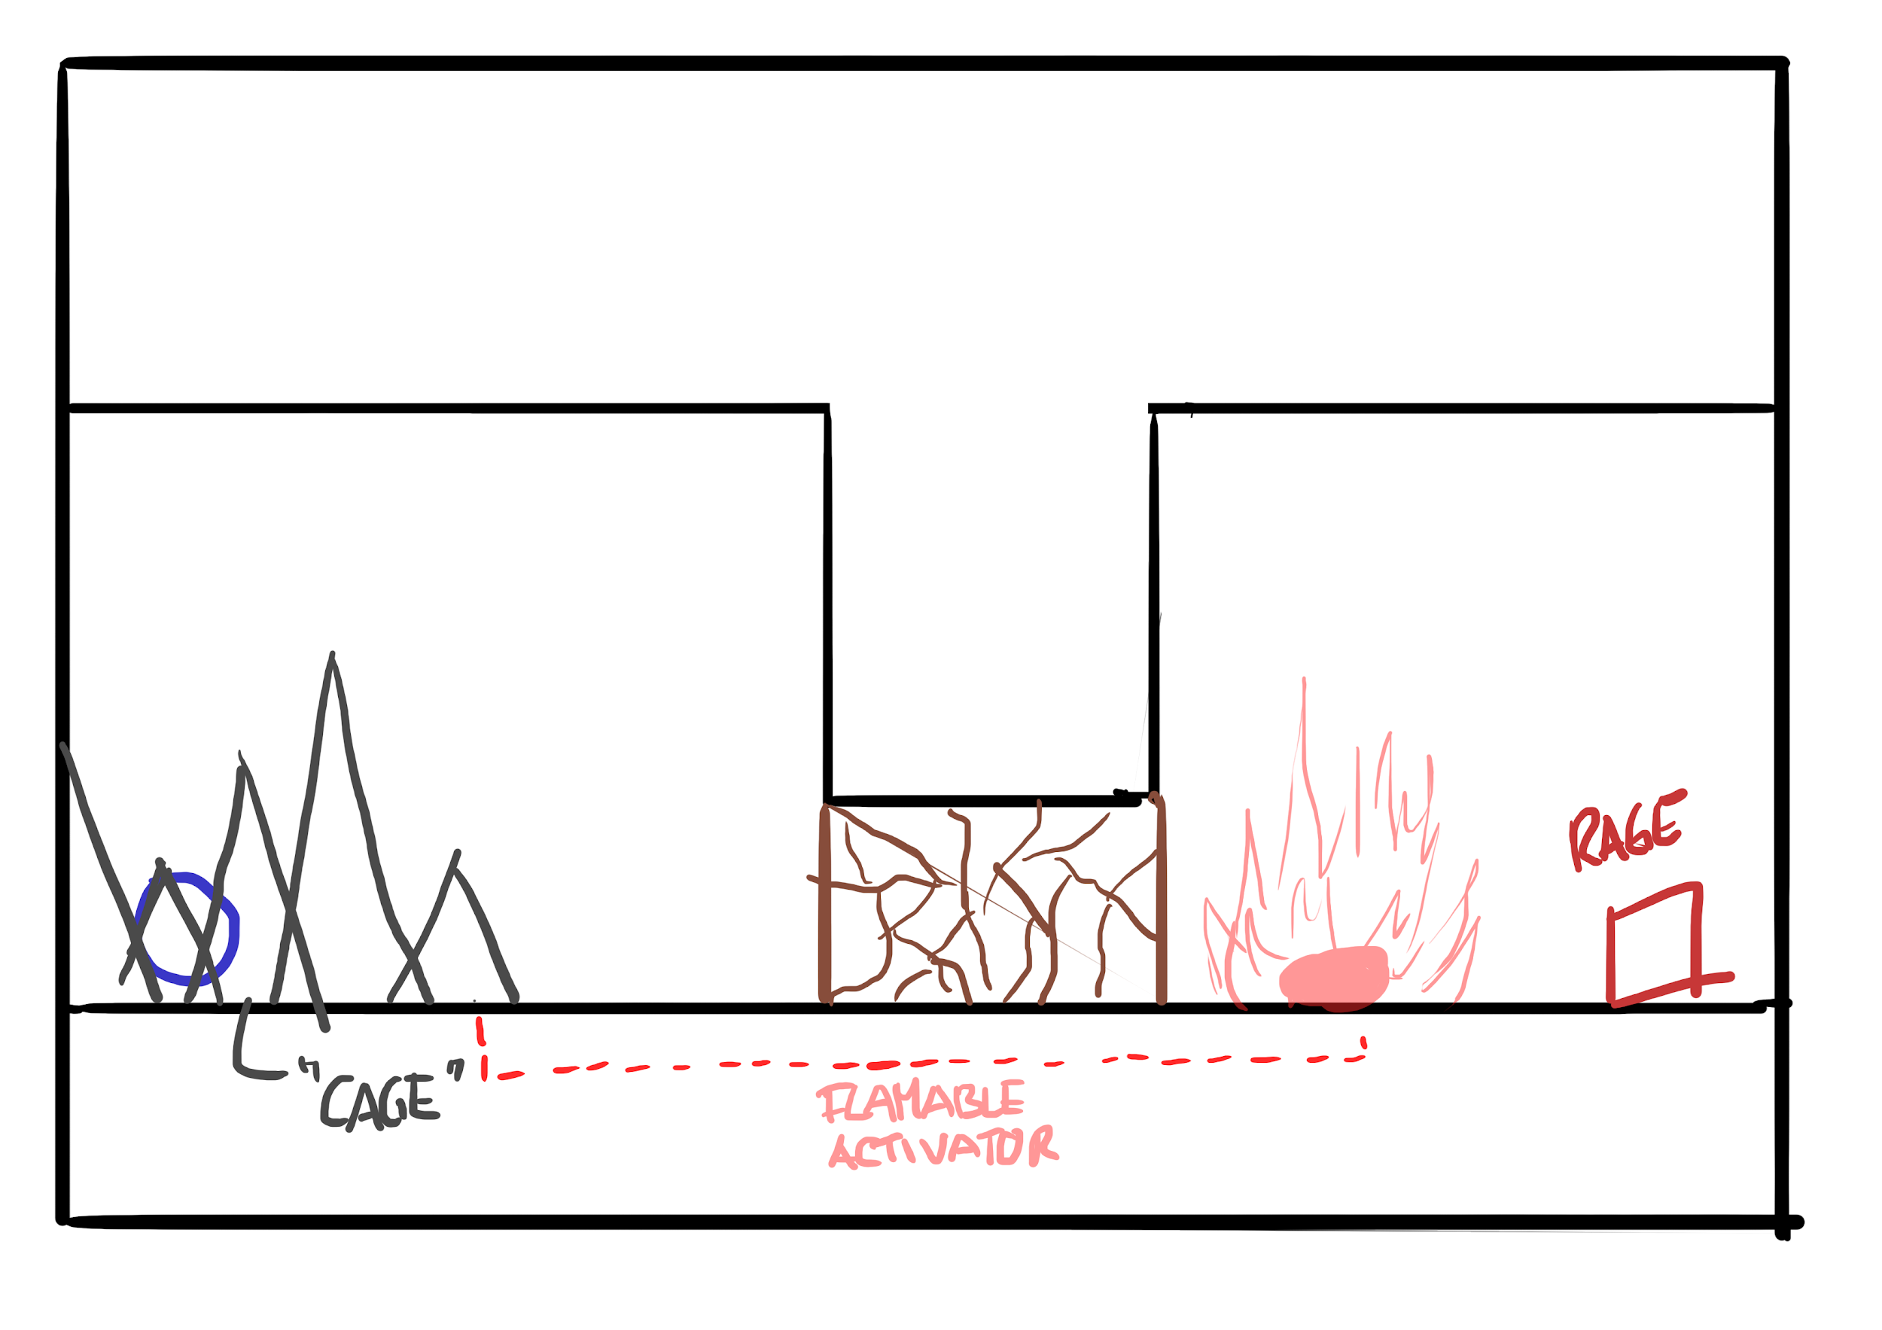

**Purpose:** Introduce the player to the character *Sadness*  and its’ abilities  
**Character:** Rage and Sadness  
**Interactive Objects:**

* Destructible stone (wall)
* Flammable activator to retract the “prison spikes” (similar to the spike retraction with the lever in Daniel’s first Idea)

**Solution:**1. activate Rage’s ability to activate the flame and burst through the wall.   
2.Collect sadness and calm rage down

3. use Sadness’s ability to extinguish the flame and exit the level

**(3) level idea - Rage, Sadness and Anxiety (Only bacic abilities)**

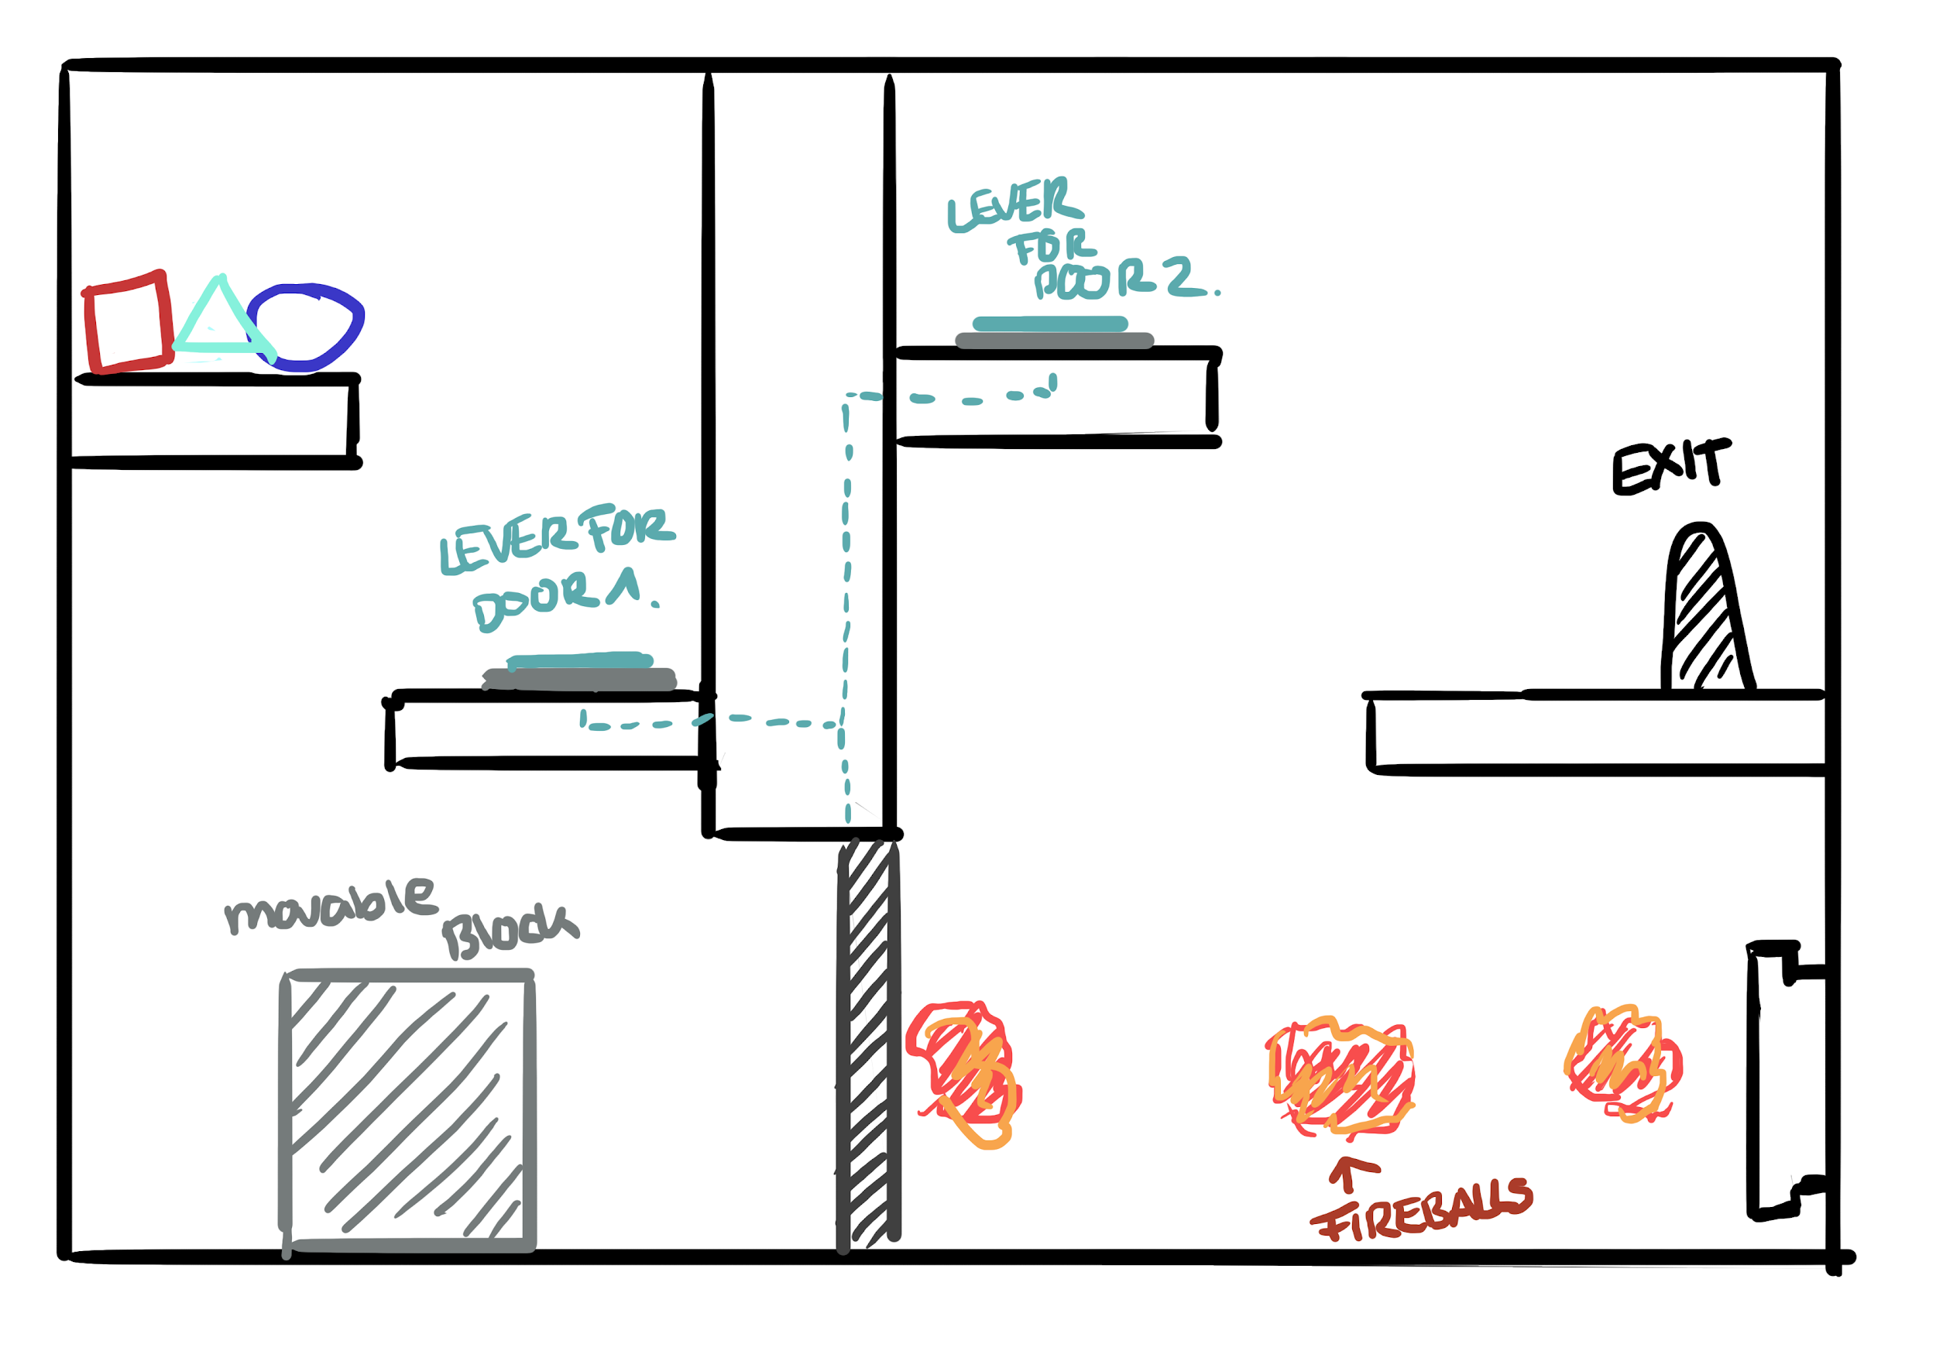  
**Character:** Rage, Sadness and Anxiety  
**Interactive Objects:**

* levers/Buttons for the retractable door
* movable block that can take 3 hits
* fireballs

**Solution:**1. Anxiety is positioned right in front of the door

2. sadness stands on the lever/button to open the door

3. Anxiety walks forward and freezes into place to block the fireballs and to stop the movable block at a position where the character can jump onto the block to get to the exit platform

4. Rage uses his ability to shove the movable block towards Anxiety and is stopped by anxiety

5. they should be in range to calm each other down

6. rage jumps on the block to the exit platform to the lever/button platform to have the door open so sadness can follow them this has to be done really quickly, because the block can only take 3 hits

7. sadness follows them to the exit platform.

**Questions:   
-**Can they use their abilities instantly after they calmed down?

**-**What happens when they get hit by a projectile?

CHANGES:  
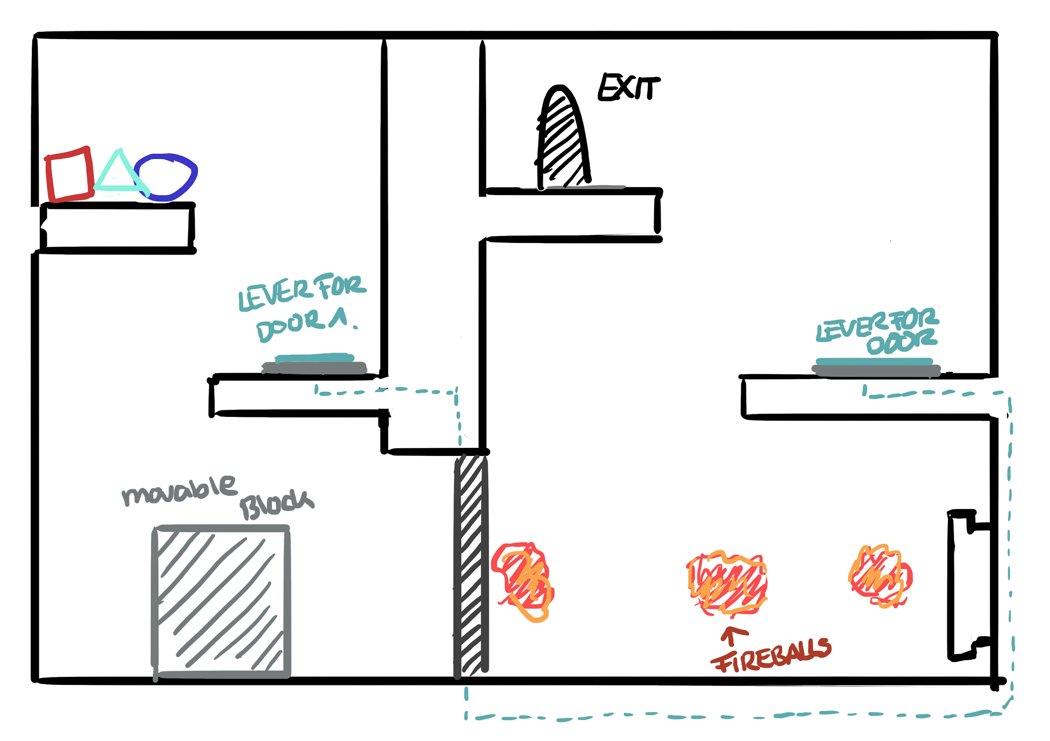  
The Level above was designed for only the basic abilities in mind, which does not make sense with all three characters in the level, so i made a very subtle change.   
The exit and the lever for the door just changed places. Because this visualization is not scaled correctly the exit platform would be so far away, that the characters cannot jump onto it. The solution steps stay the same until step 6  
  
**Solution:**1. Anxiety is positioned right in front of the door

2. sadness stands on the lever/button to open the door

3. Anxiety walks forward and freezes into place to block the fireballs and to stop the movable block at a position where the character can jump onto the block to get to the exit platform

4. Rage uses his ability to shove the movable block towards Anxiety and is stopped by anxiety

5. they should be in range to calm each other down

6. rage jumps on the platform with the door lever 2 and opens the door.   
7. Sadness goes through the door and jumps with anxiety onto the lever platform, all three character should be on this platform

8. Use the combined ability of Sadness and Rage to form a pathway to the exit platform

9. Collect Rage and Sadness with Anxiety and proceed towards the exit.

**(4) level idea - Rage, Sadness and Anxiety (Easy)**

This Idea was created with the thought that the Magma Tears cannot reach endlessly, so if there is a very huge gap they may not cross it because they cannot reach that far.   
**Character:** Rage, Sadness and Anxiety  
**Interactive Objects:**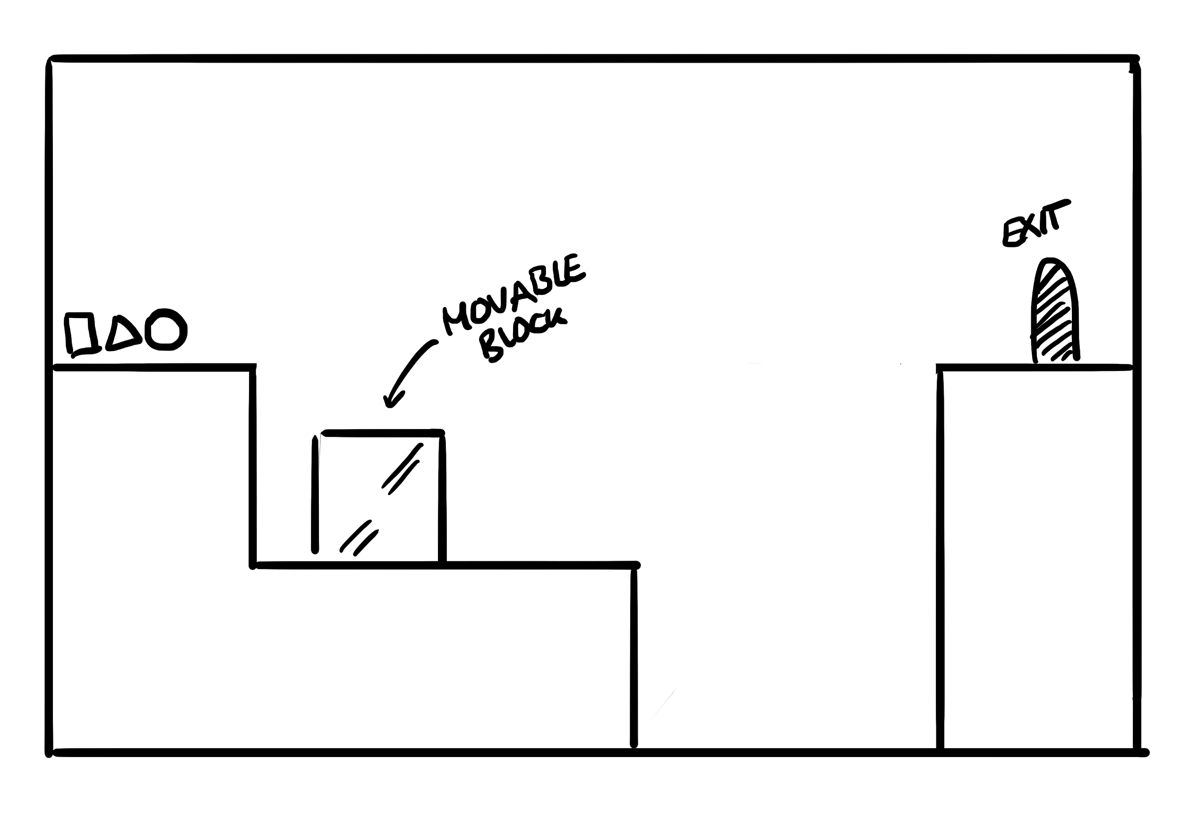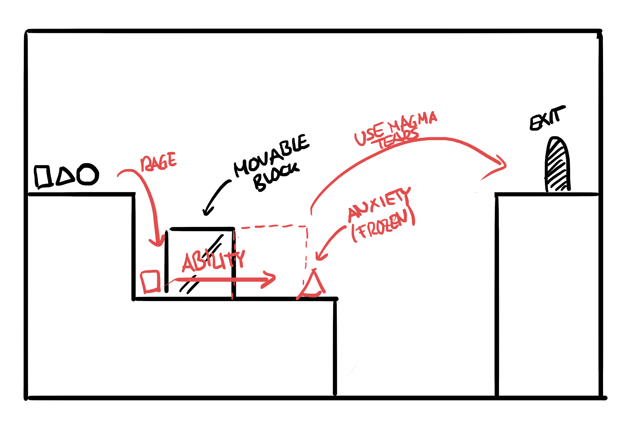

* movable block

**Solution (on the right visualization):**1. Anxiety freezes right before the gap

2. Rage uses Rampage to move the block towards Anxiety, which stops the block and Rampage

3. Sadness can collect them both (or they collect each other)

4. Rage and Sadness use Magma Tears to form a pathway to reach the exit platform

5. Collect them with Anxiety and proceed toward the exit

**(5)level idea - Rage, Sadness and Anxiety**

This level only works if sadness can use his Jetpack like ability for a vertical movement, which produces pressure. I created this level before the Final Character Sheet where we played around with the Jetpack-Tear-Idea. The Final Character Sheet states that Sadness can propel itself upward if **aimed** at the ground, does that count for vertical movement as well, if you **aim** at the wall beside you to get a boost. However, because we are collecting Ideas I thought I’ll post it anyway   
 **Character:** Rage, Sadness and Anxiety  
**Interactive Objects:**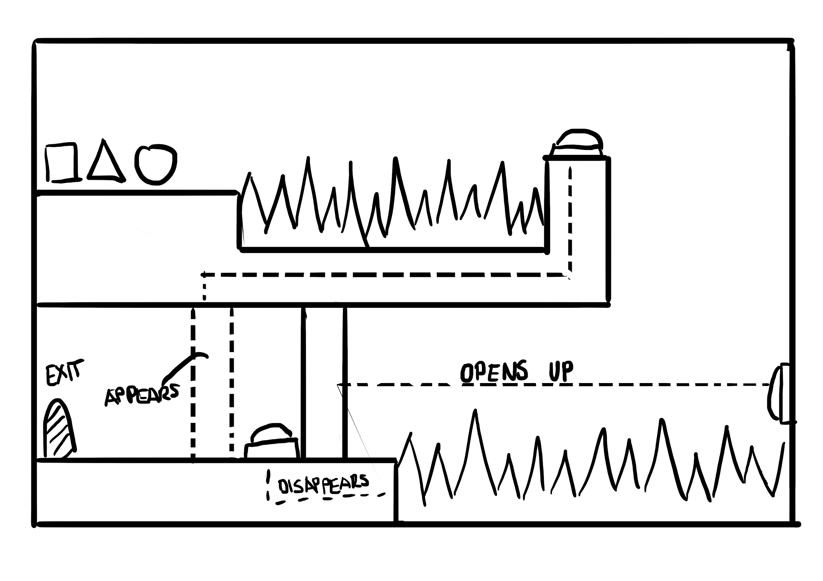

* lever/button to make a door appear
* lever/button to make a door disappear
* lever/button to make spikes disappear
* spikes

**Solution (on the right visualization):**1. Use Magma tears to create a bridge over the first spikes.

2. Collect them with Anxiety

3. Let Rage stand on the lever /button to make the barrier door appear, this barrier will be used to trap Sadness in the space between the two doors and enables sadness to perfectly land on the lever for the spikes (if the player has perfect control over the character this will not be needed)

4. Anxiety drops down on the spiked and freezes, so it becomes a platform  
5. Sadness lands on Anxiety and aims at the lever/button to open the door. It propels him vertically towards the barrier door, that stops sadness and it lands on the lever/button below to retract the spikes

6. Rage collects Anxiety, they continue to collect Sadness and proceed toward the exit

**(6)level idea - Rage, Sadness and Anxiety  
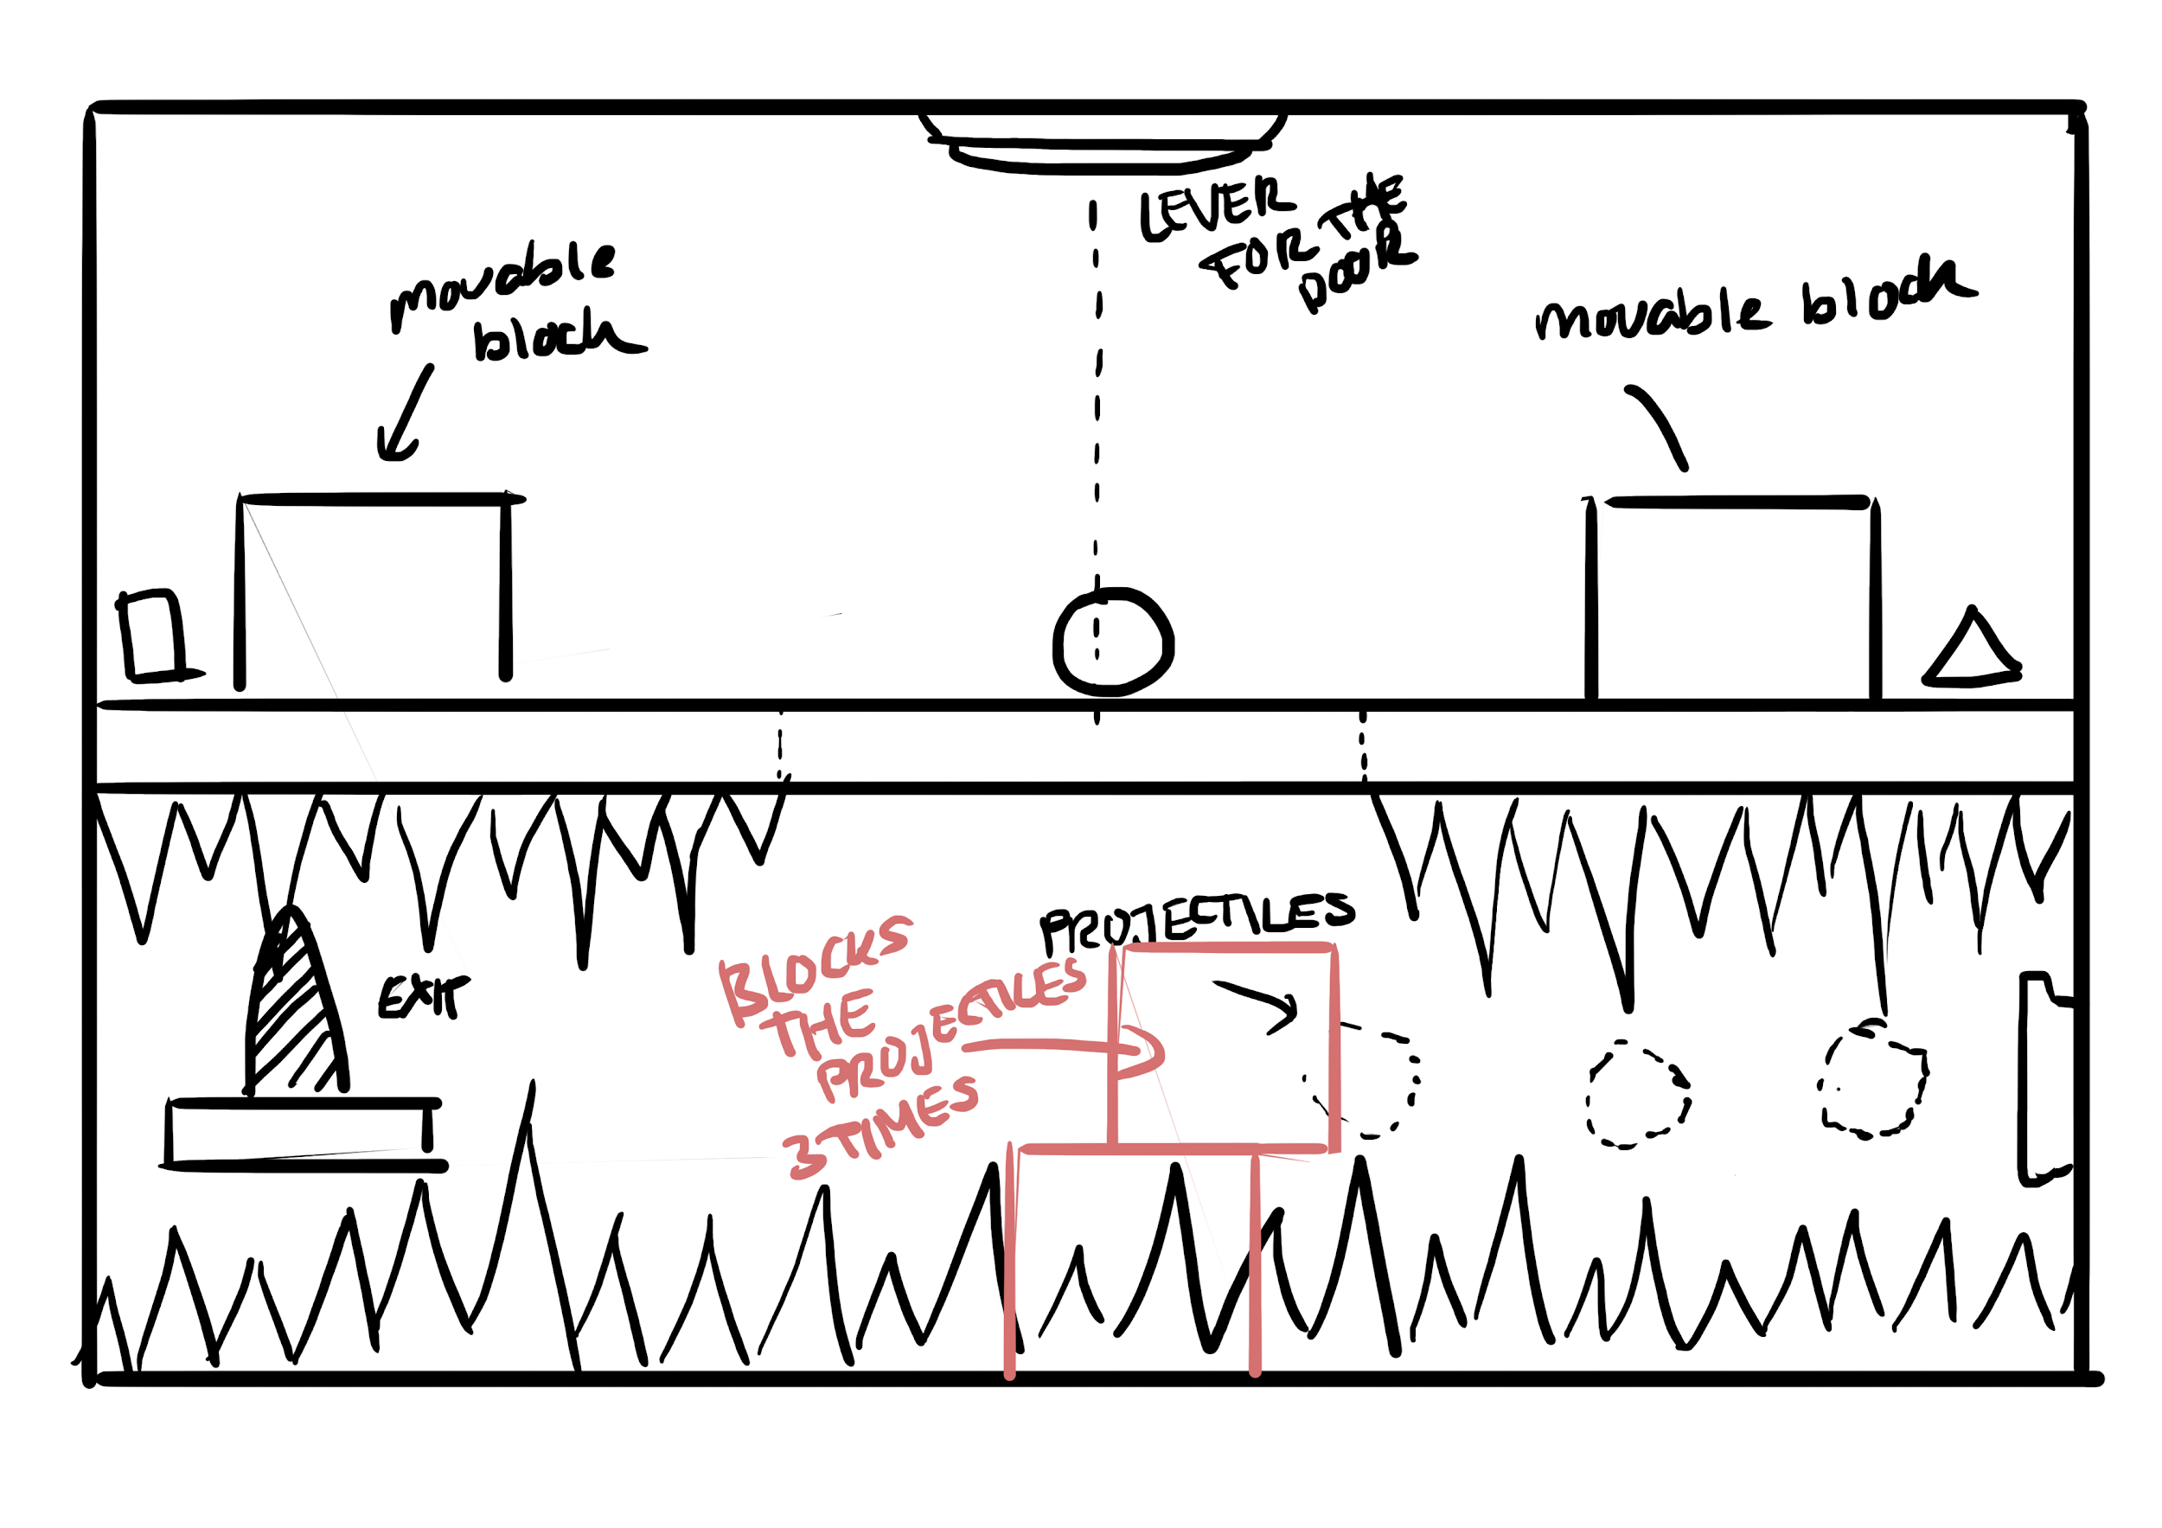**

**Question:** Is meeting up a controlled action? If they all stand together and use their ability once they kind of meet up, but they are not really in control.   
 **Character:** Rage, Sadness and Anxiety  
**Interactive Objects:**

* Lever/Button to open the trap door
* movable blocks
* projectiles
* spikes

**Solution (on the right visualization):**1. Use Rage and Anxiety to position one block on the trap door.

2. Calm them down with Sadness

3. Use Frozen Tears to activate the lever/button and let the block fall down.

4. Calm them down with Rage

5. Position the second block slightly off center, so it lands on the second block like it is shown in the visualization in red, so it blocks the projectiles from hitting the character during their ability (or use Anxiety to Block the Projectiles) . Jump on the block with all three character.

6. Activate the lever/button again with Frozen Tears and let the block fall with all three character on it

7. Use Magma Tears to form a path towards the exit platform

8. Calm Rage and Sadness down with Anxiety and proceed toward the exit.